DOKUMENTASI DAN REFERENSI HUMAN COMPUTER INTERACTION LAB

Nama – NIM :

* Raihan Putra Janivasya – 2440070011
* Putu Indra Yudananta – 2440108250
* Leonhard Andrew – 2440112872

Dokumentasi

1. Homepage / Landing page



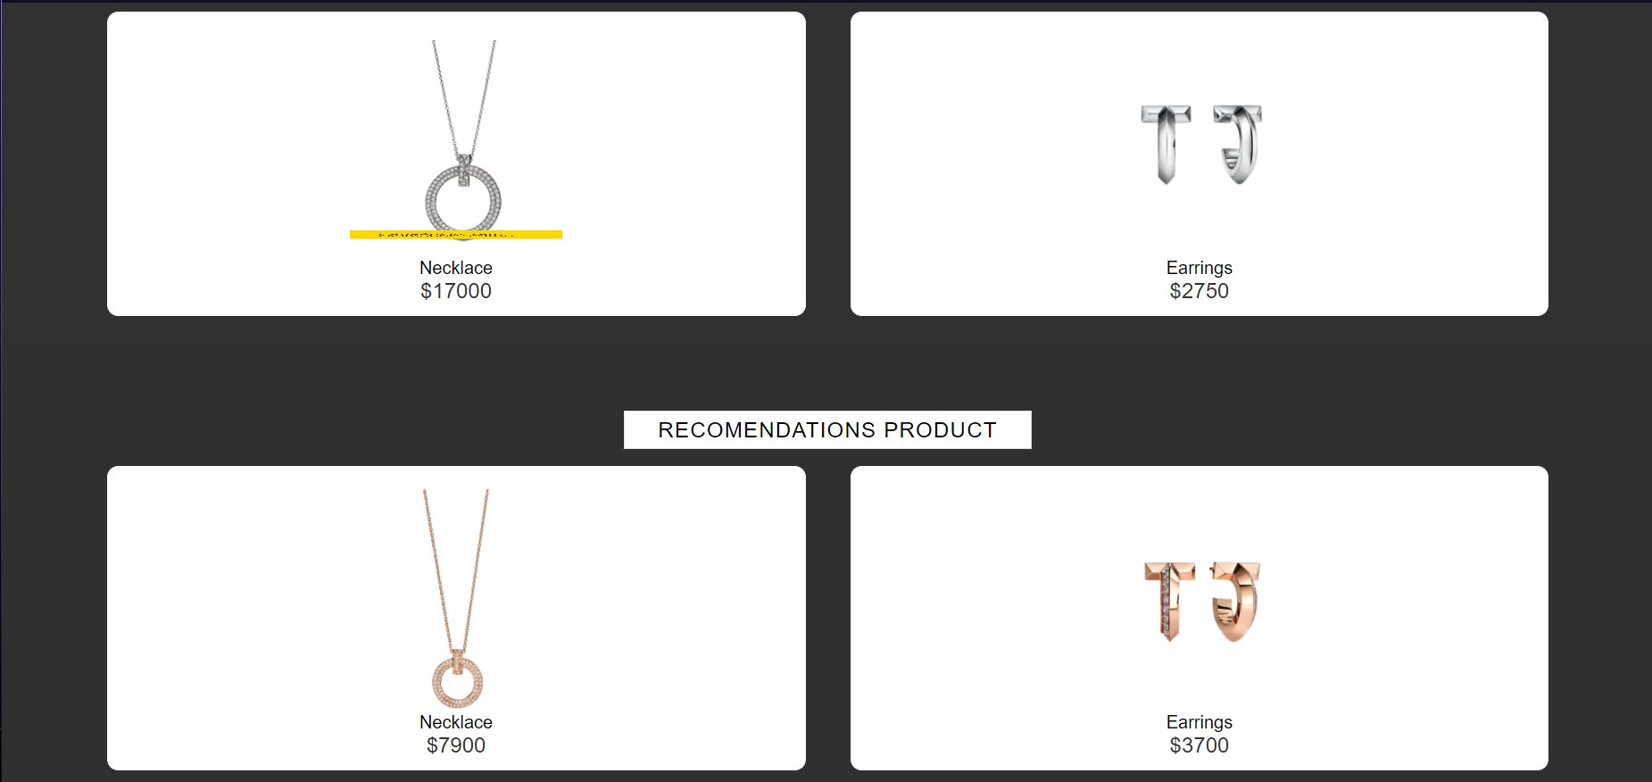



1. About Us

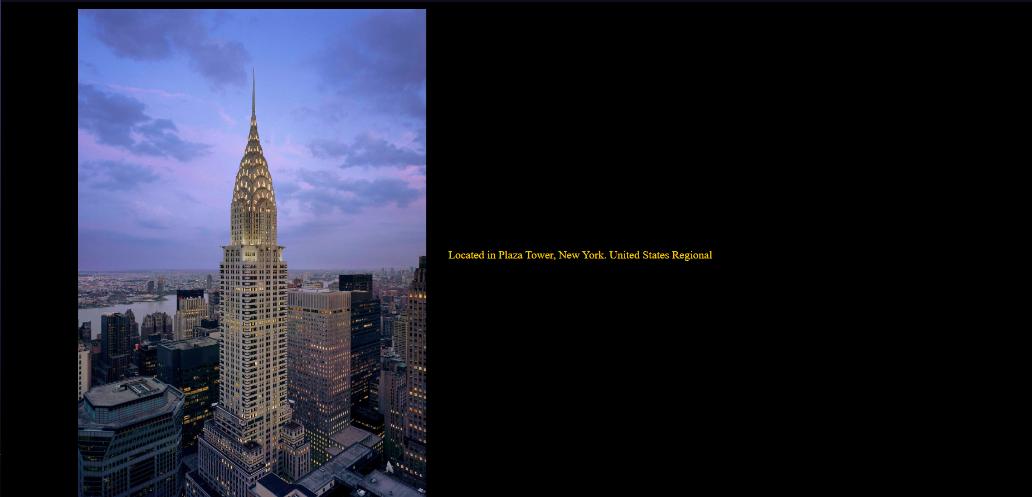

1. Promotions

1. Jewerly

White Jewerly:

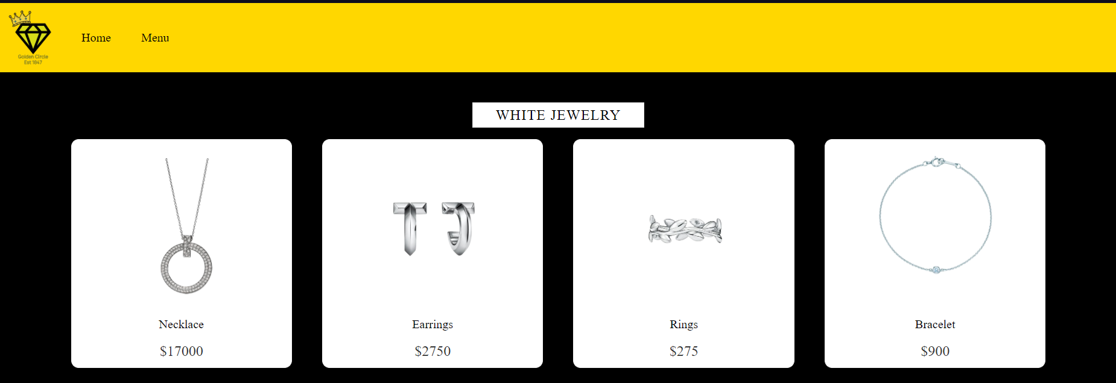

Gold Jewerly:

1. Register Membership

Referensi

<https://www.tiffany.com/>

<https://www.youtube.com/@OnlineTutorialsYT/videos>